Personal Information
First Name: |  | Mohammad | 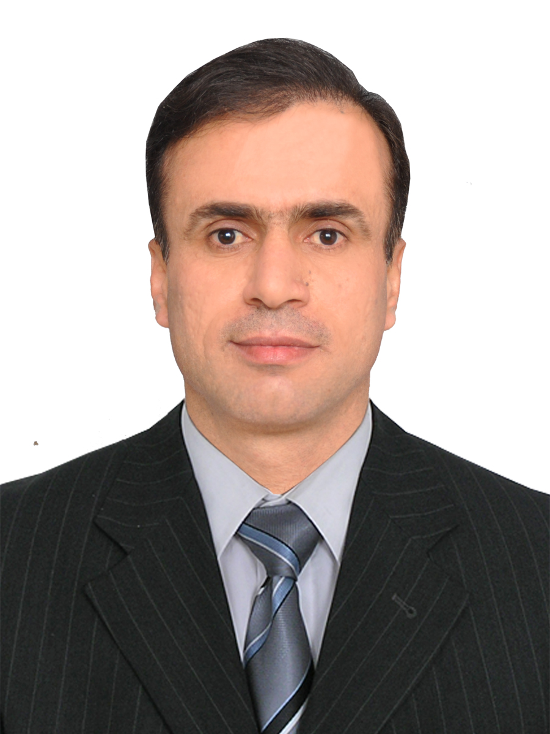
Last Name: |  | Al-abadi
Professional Title/Position: |  | lecturer
Highest Degree: |  | PhD
Affiliation: | Department/Division: | Communication
Affiliation: | University/Institute: | Diyala University
Affiliation: | City: | Diyala
Affiliation: | Country: | Iraq
Educational Qualifications: Bachelor’s in electrical and Electronic Engineering/Radar Engineering from University of Technology, Iraq. Master in Radio Technologies and Communication Systems from Kazan National Research Technical University, Russia. PhD in Antennas, Microwave devices and their Technologies from Kazan National Research Technical University, Russia.
Professional Experience: Lecturer at University of Technology and Diyala University, Iraq. Reviewer in IEEE Antennas and Wireless Propagation Letters. Reviewer in American Journal of Electromagnetics and Applications (AJEA).
Academic Achievements / Publications: many publications in IEEE, IJECE, Вестник КГТУ, Вестник ПГТУ.

